3 June 2021

Dear IPC Commissioners

Thank you for the opportunity to make further submissions on the additional material provided to the Commission.

I read the further responses from the Applicant, however, as you would expect, they are providing information as required to have the proposal accepted and with the limited time, it is not possible to discredit or dispute what they have said. Regardless, I continue to argue that strategically, this proposal is not optimizing the site.

I would like to comment on the 28/05/21 letter from the DPIE to the IPC as I continue to be concerned that their assessment (and resulting recommendation) is inadequate leading to a recommendation that is agenda driven rather than public interest driven and respectfully, it is my hope that the IPC will reach the same conclusion and if not decline this proposal, at the very least apply more stringent conditions.

My specific concerns with the additional DPIE letter are as follows:

1. Strategic Context

In section a) the DPIE state that “given the site would be used for a ports and employment purpose and it would need to utilise heavy machinery and the adjoining port, the proposal does not include public domain areas or pedestrian access through the site. However, the Department considers the proposal would not preclude the provision of connections to run within the precinct or consideration of other innovative solutions to provide public domain areas.”

“Further improvements to access to and around the site and the provision of public domain areas would be subject to further detailed planning including careful consideration of site constraints, land use conflicts and consultation with relevant stakeholders.”

My comments -
Clearly, if this batching plant is built, with the level of capital investment required, there’ll be no going back for decades. In light of all the other strategic planning such as the Bays West Structure Plan which sets visions and objectives throughout the entire precinct, is it adequate or consistent for the DPIE to recommend this proposal without knowing how public domain areas will be provided. In the DPIE’s own words, innovative solutions will be required to get around site constraints and land use conflicts and the best they could come up with is an ill-conceived idea of an elevated walkway through an industrial conglomerate is as bizarre and poorly-considered as the idea that a public park could be built above a concrete plant.

In section b) of DPIE’s response, in reference to the Draft Bays West Place Strategy it states that “further detailed planning of the sub-precincts would need to take place to minimize any land use conflicts”

“The Department has also sort to minimize impacts associated with the proposal to the greatest extent possible and has included a range of conditions to ensure the potential impacts of the proposal are appropriately mitigated and managed. This includes applying strict noise criteria based on the best achievable noised levels for the proposal”

My comments -
I remind the IPC that in the DPIE’s assessment, they stated that “strict noise criteria based on the best achievable noise levels identified by the Applicant” AND the Applicant has committed to mitigation measures that includes minimising ship noise, quote “as much as practicable”. Clearly, they chose to leave out these key words in their additional response.

In relation to policing strict noise criteria, it is a fact that the noise criteria is not strictly policed. At the moment (2-3 June 2021) there is a boat moored at Glebe Island that is horrendously noisy and without doubt exceeds specified noise levels, and the Port Authority have received many complaints. The following is the standard email that all complainants received (2 June 2021). As I have said before, the Port Authority is the fox looking after the hen house and cannot be relied on to police poor performing vessels.

On Wed, Jun 2, 2021 at 10:01 AM Enquiries <Enquiries@portauthoritynsw.com.au> wrote:
Dear Stephen,

Thank you for raising your concerns regarding the vessel AAL Shanghai with Port Authority. Details of the noise disruption you are experiencing have been escalated to our operations team for real-time investigation and action as required. Further background details on the vessel visit are below.

Glebe Island berths 1, 2, 7 and 8 are existing operational port lands with activity permitted to operate at these berths 24 hours a day, 7 days a week as required. These berths provide a low-cost, low-impact and sustainable way to bring dry bulk materials into Sydney to support the increasing demand for construction materials to service the NSW Government’s major infrastructure projects, the wider economy and jobs for the people of NSW. The port also provides opportunities to receive, store, pre-assemble and transport materials to support major infrastructure delivery.

Approximately 6,000 m2 of land near the eastern point of Glebe Island has been leased / licenced to Infrastructure NSW to support delivery of the new Sydney Fish Markets State Significant Development. Prior to the lease being issued, Port Authority assessed the operational activities proposed to occur on Glebe Island and considered that these are consistent with the use of the port, port operations and existing planning approvals. A summary of the key tasks is below:
- Site set-up and pack-up (at completion), including construction and removal of the temporary crane base, hardstands and concrete support structures
- Receiving, unloading, handling, storage, sorting, and/or transport off-site of building materials including; piles (foundations), and other structural steel, timber or concrete elements such as beams, columns, panels and planks
- Pre-assembly, alteration or rectification of miscellaneous building materials and loading onto barges via mobile crane prior to delivery to the new Sydney Fish Markets
- Berthing of tugs and barges serving the New Sydney Fish Markets project

The vessel AAL SHANGHAI is berthed at Glebe Island berth 2 (GLB2) for the purpose of unloading (and temporary storage), of piles (foundation materials), for the new Sydney Fish Market Project at the head of Blackwattle Bay. The benefits of delivering these large construction elements by ship into Glebe Island is the removal of a significant number of truck movements from our roads. Road transport would require a large number of trucks traveling far greater distances and through Sydney to deliver large construction elements to the Fish Market Project.

Port Authority anticipates the vessel will remain at berth for approximately 2 days. At this time, the ship is planned to depart on Thursday 3 June at approx. 6pm.

Activities associated with the vessel visit are required to be carried out in accordance with Port Authority’s planning approval for the berths at Glebe Island 1 and 2 which allow for ad hoc port activity.

During its stay, the ship’s generator will continue to run as required to support liveable conditions for the crew onboard (e.g. for lighting, air conditioning, refrigeration, and other onboard systems). The vessel operator has been reminded that the berths at White Bay and Glebe Island are adjacent to residential areas and noise and light emissions from the vessel and site activities should be minimised throughout its stay, whilst ensuring safe operations. The ship’s master is also required to ensure the ship’s generators/engines are maintained and operating efficiently to reduce noise and air emissions while in port.

In this instance, Port Authority did not carry out pre-arrival noise monitoring. This is because this is not the typical type of vessel that will be using the port on a regular basis. Attended noise measurements for the AAL Shanghai were carried out last night. At this time, the results have not yet been provided to Port Authority.

Should you have an enquiry or wish to lodge a complaint related to this visit, please call our 24/7 community enquiries and complaints line on 02 9296 4962. This will prompt a real-time investigation into your issue.

I hope this information assists. We thank you for your patience during this visit.
Kind regards
Tara Kennedy | Community Relations Manager
Port Authority of New South Wales

I can report that the ship operator being reminded about being adjacent to residential areas made no difference to the noise levels overnight. Further the Port Authorities lack of commitment to noise control is obvious by the statement that they “did not carry out pre-arrival noise monitoring” “because this is not the typical type of vessel that will be using the port on a regular basis”. Frankly, that is simply untrue. My experience is that this is typical of the vessels that have been using the port on a periodic basis.

In my opinion, we cannot rely on the Port Authority to police noise, so the fact that the level of minimisation of impacts applied by the DPIE in its assessment are based on noise levels identified by the applicant is extremely concerning. Also concerning is the DPIE’s attempt to justify this proposal despite the fact that no cumulative environmental impacts have been assessed.

Further, government agencies such as the EPA, have historically done nothing with breaches, nor are their fines significant enough to change behaviours or achieve any significant impact on the already-well-publicised toxic outputs of other Hanson plants.

Anecdotally, I attach photos of oil slicks surrounding the vessel (taken 3 June 2021). What will be the environmental impact when there are significantly more ships coming and going 24/7 and what will the various government agencies do about such examples other than remind the ship operators that they have a responsibility not to create such oil slicks? I note that the “predicted outcomes” in the various Environment Impact Statements prepared by the Applicant, agreed by the DPIE and ultimately policed by the Port Authority is that the “predicted outcomes” are acceptable……

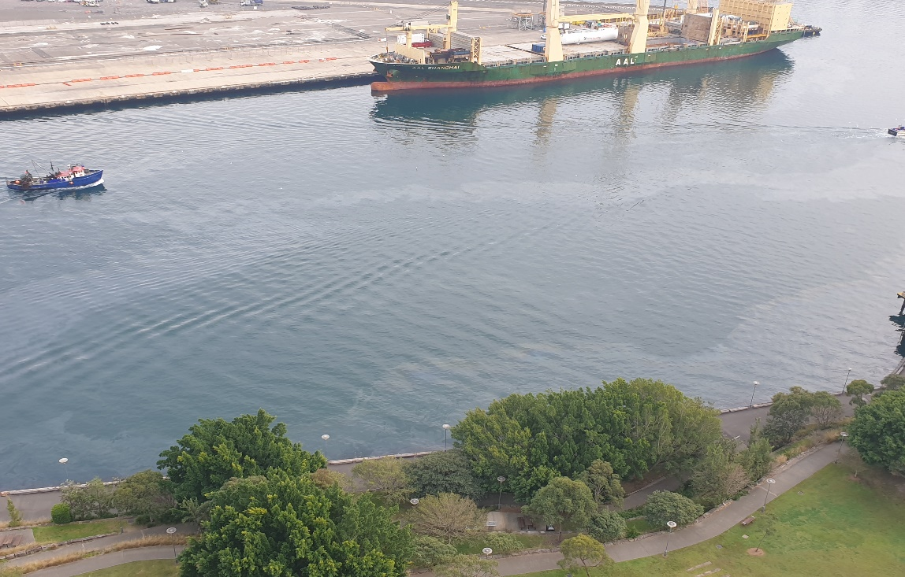

2. Height details

The DPIE state that “the height of the ANZAC Bridge deck at the pylon structure closest to the proposed development is RL 30.63 AHD. And both the applicant and DPIE confirmed that the Aggregate Storage Shed silos will be RL 37.6m.

My comments -

So, the DPIE are saying that it is acceptable for the Aggregate Storage Silos to be 7m higher than the Anzac Bridge carriageway. This is a point that the proposal’s opponents have been consistently making and goes to the enormous size and scale of this facility. As already demonstrated in the public meeting, the size and scale of the proposal would not only dominate the landscape but also produce highly detrimental effects on viewlines to existing heritage structures as well as blocking important views throughout the Bays and to/from as far away as Barangaroo and the Harbour Bridge.

Further, one of the innovative solutions mentioned by the DPIE for the public domain dilemma is for an “elevated public domain”. With silos that are already 7m over the Anzac Bridge deck, any suggestion of a public park is a fantasy, and makes me wonder why the DPIE are making such unrealistic, and unlikely statements. This to me raised the agenda vs public interest question.

The carefully-avoided Glebe Island & White Bay Master Plan 2000 provides two building zones – one for buildings of up to 10,000sqm in floor area and 12m maximum height and one for a 6-7 level parking structure of up to 25m maximum height. Nothing over 25m! As stated by the DPIE, the height of the Multi-User Facility is approximately 24.2 AHD, which essentially complies with this limit, so why is Hanson allowed to exceed this?

3. Landscaping

In section a), ”The Department accepts that landscaping would not screen the proposed taller structures, and there are currently no deep soil zones on the site that would allow large trees to be planted. The Department also accepts that the site is bounded to the north by the Multi-user facility and the south by the existing Glebe Island Bridge abutments.”

My comments -
There’s a saying, you can’t make a purse out of a sow’s ear. Well, this is the case here, but any landscaping would be better than nothing.

I would make the point that the DPIE accept that with no deep soil zones it would be hard to plant large trees, yet they say it is possible to build a park above silos that are 34 metres high…..really???

4. Noise / Enclosure of Structures

Please refer to my earlier comments in relation to ship noise.

In section a) the DPIE state that the Applicant has committed to carrying out all concrete batching and truck unloading activities within fully enclosed buildings. Further in section b), the DPIE stated that the Applicant’s EIS states that the silos would be constructed out of concrete and the Department has assessed the proposal on this basis. The Noise Assessment does not specify that the buildings (including the silos) need to be a specific material or acoustically treated to meet the relevant noise criteria.

My comments -
Whilst the silos are constructed out of concrete, it is my understanding that the building enclosing the concrete batching and truck unloading will effectively be a tin shed with no sound insulation. I recall this was confirmed in the IPC hearing.

It is concerning that the DPIE have not requested or conditioned any significant noise-control assessment nor does it appear to have involved any input from an acoustic consultant as to what noise levels are likely to emanate from the facility. Unfortunately, the DPIE assessment hasn’t even tried to scratch the surface of this proposal, and blindly accepted information provided by the Applicant, and in doing so, have potentially not acted in the public interest.

This level of apathy from both parties to issues of serious public concern is both obvious and gobsmacking, especially for a State Significant Development. Whilst the noise assessment did not specify a specific material, is it not incumbent on the DPIE to ensure that whatever the design is, addresses an area of significant public concern prior to approval? Surely any building on a State Significant Site requires full architectural design by an eminent architect, through a competitive process, especially when significant environmental outcomes are obvious issues.

5. Traffic

In section a) the DPIE stated “The traffic modelling (based on a worst-case scenario considering cumulative impacts) indicates the southern leg of The Crescent experiences significant delays (under current and future operating conditions). Queuing on the southern leg of the intersection (i.e. the northbound traffic on The Crescent approaching the intersection) is modelled to extend up to approximately 840 m.”

The Department notes “the Applicant’s TIA assessed impacts prior to the opening of the Rozelle Interchange. If the proposal is not operational until 2024 (as now advised by the Applicant), the Rozelle Interchange is planned to be open by this time, providing relief to the road network.”

My comments -
This is back of the postage stamp stuff. By the DPIE’s own admission, there will be significant traffic delays, and have trivialized it by assuming the Rozelle Interchange will provide relief. This seems a rather casual approach to what is a serious issue. There is no evidence or quantification of the supposed relief, just an assumption. In section c) the DPIE stated that the Applicant “cannot specify an hour-by-hour breakdown of the frequency” of trucks. Therefore, the DPIE cannot possibly know how much relief will be provided by the Rozelle Interchange. It no doubt will provide some relief, but that is a matter of degree and with thousands of trucks in and out of Glebe Island, the potential to cripple traffic on and around Anzac Bridge requires more than just an assumption.

6. Construction period

I have no comment to make about the construction period, other than to make an observation about the DPIE’s response to the IPC question “The Applicant has indicated that the construction period would be 18-24 months with completion around 2024. Please confirm this is the period that the Department based its assessment on and provide any further comments, if necessary.”

The DPIE’s response was that it “based its assessment on the construction timeframe specified in the Applicant’s EIS which states that construction would be undertaken over a six to nine-month period, with operations commencing in mid-2022.”

My comments -
This a small example of the inconsistencies and dangerous reliance by the DPIE on information provided by the Applicant, and why I believe that the DPIE have not been diligent enough in their scrutiny of this proposal.

CONCLUSION
In my opinion the DPIE assessment has not been diligent enough, resulting in a recommendation that is not in the public interest. This additional material does not change my original submission to the IPC that this proposal is a strategic mistake and should not be allowed to proceed. Further, if it was to proceed, significantly upgraded mitigation and conditions beyond what the DPIE have suggested would be required.

I respectfully ask the Commission to refuse this application.

